***Task 1:***

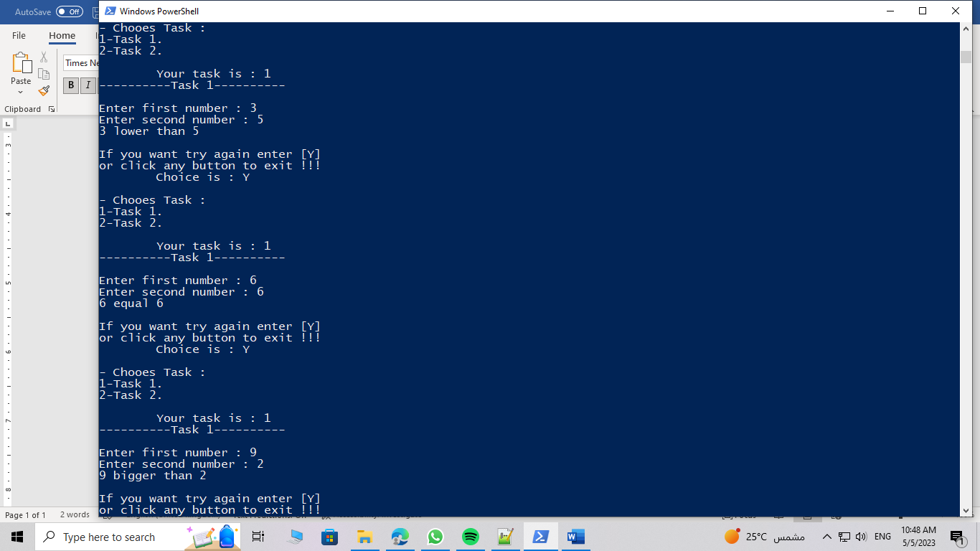

***Task 2:***

